

image recognition for



diseasse diagnosis

Title: Image Recognition for Disease

Diagnosis: A Comprehensive Report

Introduction:

image recognition has emerged as a powerful tool in the field of healthcare, particularly in disease diagnosis. This report explores the advancements, challenges, and applications of image recognition in medical contexts, focusing on its role in disease detection.

**Background:**

**image recognition utilizes artificial intelligence (AI) and machine learning algorithms to analyze and interpret medical images. In the context of disease diagnosis, this technology has proven effective in identifying patterns and anomalies that might be indicative of various medical conditions.**

Advancements in Image Recognition for Disease Diagnosis:

**a. Deep Learning Techniques: Convolutional Neural Networks (CNNs) and other deep learning architectures have demonstrated remarkable success in image recognition. These techniques enable the automatic extraction of complex features from medical images, improving diagnostic accuracy.**

**b. Transfer Learning: Transfer learning, where pre-trained models are adapted to specific medical datasets, has accelerated the development of image recognition applications for disease diagnosis. This approach leverages knowledge gained from one domain to enhance performance in another.**

Applications:

a. Cancer Detection: Image recognition plays a crucial role in the early detection of various cancers, such as breast cancer, lung cancer, and skin cancer, by analyzing medical imaging data like mammograms, CT scans, and dermoscopic images.

b. Neurological Disorders: In the realm of neurology, image recognition aids in the diagnosis of conditions like Alzheimer's disease, multiple sclerosis, and stroke by analyzing MRI and CT scans.

c. Cardiovascular Diseases: Identification of cardiovascular diseases is facilitated through image recognition techniques applied to echocardiograms, angiograms, and other cardiac imaging modalities.

Challenges and Considerations:

a. Data Privacy and Security: The use of sensitive medical images raises concerns about patient privacy and data security. Striking a balance between data accessibility for research and protecting patient information is crucial.

b. Interoperability: Standardization of medical image formats and interoperability among different healthcare systems remain challenges that need to be addressed for widespread adoption.

c. Ethical Considerations: Ethical considerations, including biases in training data and the impact on healthcare disparities, need to be carefully addressed to ensure fair and equitable deployment of image recognition technologies.

Future Directions:

a. Explainable AI: Enhancing the interpretability of image recognition models is crucial for gaining trust among healthcare professionals. Efforts in developing explainable AI will pave the way for wider acceptance.

b. Integration with Electronic Health Records (EHR): Seamless integration of image recognition systems with EHRs can enhance diagnostic workflows and provide a holistic view of patient health.

Previous works related to your idea

• "Automated detection of lung diseases using chest X-ray images: A review" by S. Sathya and S. Sivakumari. This review article summarizes the state-of-the-art in automated detection of lung diseases using chest X-ray images. It discusses various machine learning and deep learning approaches for disease diagnosis and highlights the challenges and future directions in this field.

• "Automated diagnosis of skin cancer: A review" by M. Emre Celebi et al. This review paper provides an overview of automated systems for the diagnosis of skin cancer using dermoscopy images. It discusses the use of image processing and machine learning techniques for lesion segmentation, feature extraction, and classification of skin lesions.

• “Deep learning for brain MRI segmentation: State of the art and future directions" by S. Mehta et al. This paper focuses on the application of deep learning for brain MRI segmentation, which is essential for the diagnosis of various neurological disorders. It discusses the challenges and opportunities in using deep learning for accurate and efficient brain image analysis

•      "Computer-aided diagnosis in medical imaging: Historical review, current status and future potential" by Bram van Ginneken. This article provides a comprehensive overview of computer-aided diagnosis in medical imaging, including the use of image recognition techniques for disease diagnosis. It discusses the evolution of CAD systems, their current status, and future potential in improving diagnostic accuracy and efficiency.

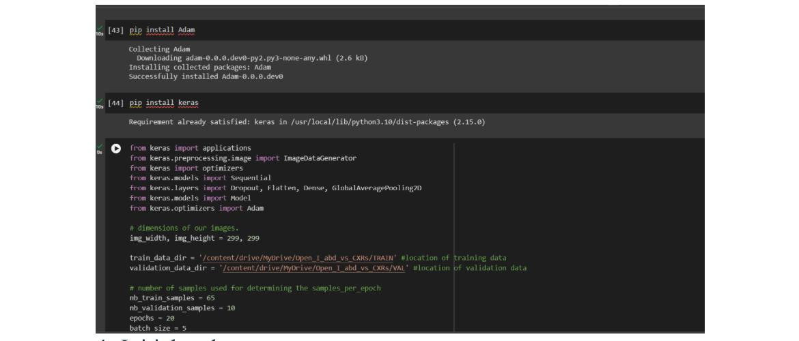

Initial code:

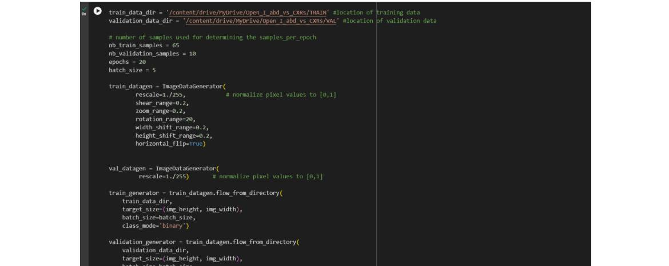

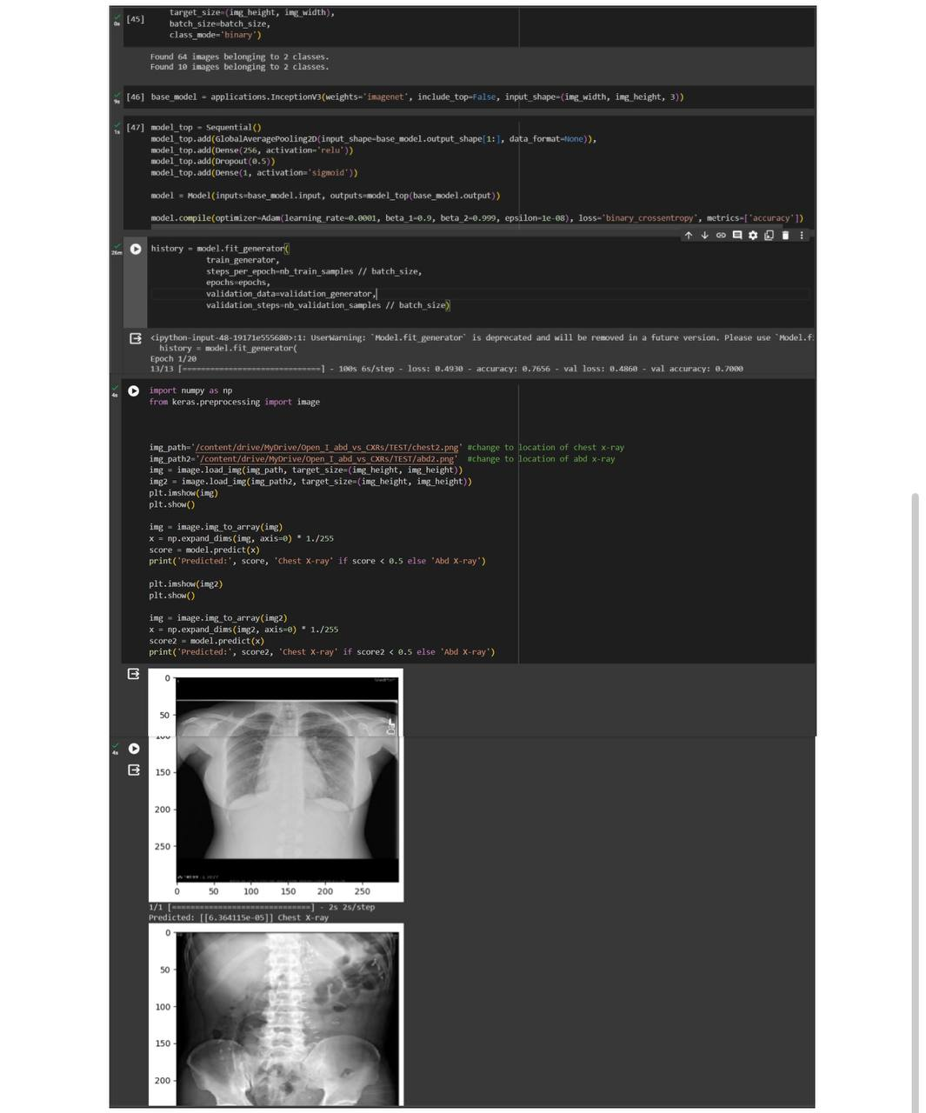

Conclusion:

Image recognition holds immense potential for revolutionizing disease diagnosis in the healthcare sector. As advancements continue and challenges are addressed, the integration of AI-driven image recognition tools is poised to significantly impact the accuracy and efficiency of medical diagnoses, ultimately improving patient outcomes.